***Lecture One − Applications of Definite Integrals***

***Section* 1.1 – Velocity and Net Change**

**Velocity, Position, and Displacement**

***Definitions***

1. ***Position*** of an object at time *t*, denoted , is the location of the object relative to the origin.
2. ***Velocity*** of an object at time t is 
3. ***Displacement*** of the object between  and  is



1. ***Distance traveled*** by the object between  and  is

 where  is the speed of the object at time *t*.

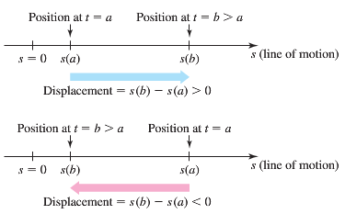

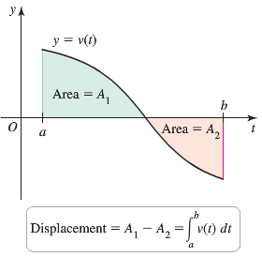 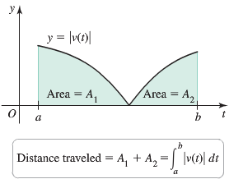

***Example***

A cyclist pedals along a straight road with velocity  for , where *t* is measured in hours.

1. Graph the velocity function over the interval [0, 3]. Determine when the cyclist moves in the position direction and when she moves in the negative direction.
2. Find the displacement of the cyclist (in miles) on the time intervals [0, 1], [1, 3], and [0, 3]. Interpret these results.
3. Find the distance traveled over the interval [0, 3]

***Solution***

1. 

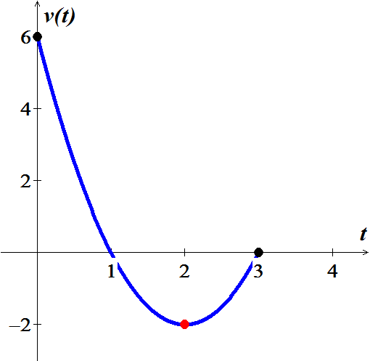

The velocity is zero at *t* = 1 and *t* = 3.

The velocity is positive on , which means the cyclist moves in the positive *s* direction.

The velocity is negative on , which means the cyclist moves in the negative *s* direction.

1. Displacement over [0, 1]











Displacement over [1, 3]









Displacement over [0, 3]







 The cyclist returns to the starting point after 3 hours.

1. 







|  |  |
| --- | --- |
|  |  |
| Displacement from *t* = 0 to *t* = 3 is 0 |  |

**Future Value of the Position Function**

***Theorem***

Given the velocity  of an object moving along a line and its initial position , the position function of the object for future times  is



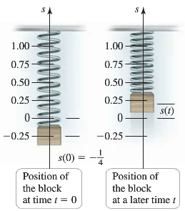***Example***

A block hangs at rest from a massless spring at the origin (*s* = 0). At , the block is pulled downward  to its initial position  and released. Its velocity is given by  for . Assume that the upward direction is positive.

1. Find the position of the block for 
2. Graph the position function for .
3. When does the block move through the origin for the first time?
4. When does the block reach its highest point for the first time and what is its position at that time?
5. When does the block return to its lowest point?

***Solution***

|  |  |
| --- | --- |
| **1st *method*** | **2nd *method*** |
| Since , then |  |

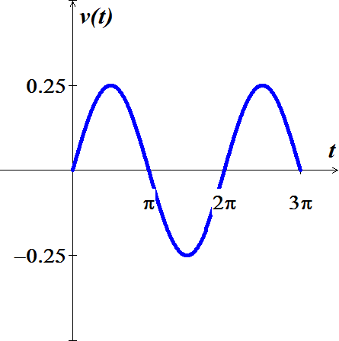 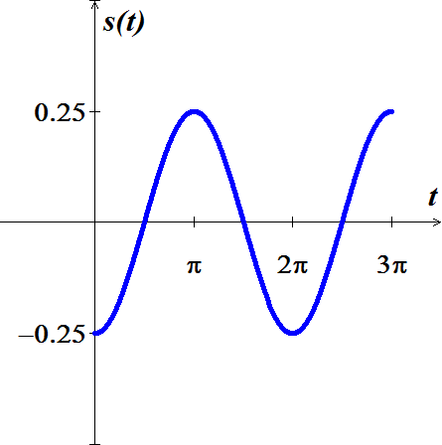

1. The block move through the origin for the first time when 



1. The block moves in the positive direction and reaches its high point for the first time when 



1. The block return to the lowest point at . This motion repeats every  seconds

***Example***

Suppose a skydiver leaps from a hovering helicopter and fall in a straight line. He falls at a terminal velocity of 80 *m/s* for 19 *sec*, at which time he opens his parachute. The velocity decreases linearly to 6 *m/s* over two-second period and then remains constant until he reaches the ground at *t* = 40 *s*. The motion is described by the velocity function



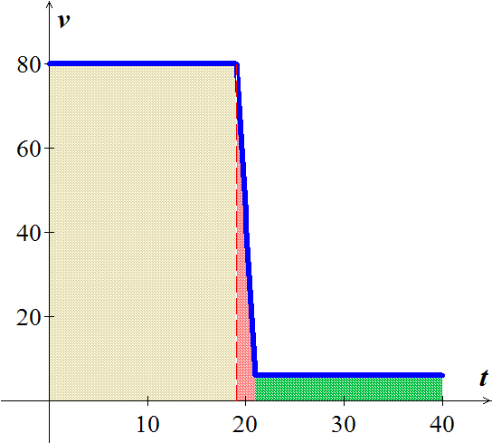Determine the altitude from which the skydiver jumper.

***Solution***



 

 





The skydiver jumped from 1720 *m* above the ground.

***Acceleration***

***Theorem*** (velocity from Acceleration)

Given the acceleration  of an object moving along a line and its initial velocity , the velocity of the object for future times  is



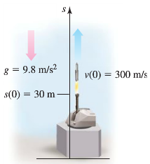***Example***

An artillery shell is fired directly upward with an initial velocity of 300 *m/s* from a point 30 *m* above the ground. Assume that only the force of gravity acts on the shell and it produces an acceleration of 9.8  . Find the velocity of the shell for 

***Solution***



 ***Upward***



The velocity decreases from its initial value of 300 *m/s*, reaching zero at the high point of the trajectory when



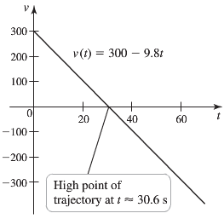

At this point the velocity becomes negative, and the shell begins its descent to Earth.

**Net Change and Future Value**

***Theorem***

Suppose a quantity *Q* changes over time at a known rate . Then the net change in *Q* between  and is





Given the ***initial value*** , the ***future value*** *Q* at future times  is



|  |  |
| --- | --- |
| ***Velocity−Displacement Problems*** | ***General Problems*** |
| Position | Quantity  (such as volume or population size) |
| Velocity: | Rate of change |
| Displacement: | Net change: |
| Future position: | Future value of *Q*: |

***Example***

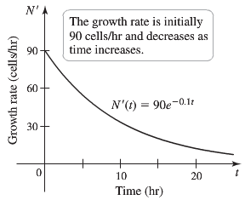A culture of cells in a lab has a population of 100 cells when nutrients are added at time . Suppose the population  increases at a rate given by



Find  for 

***Solution***



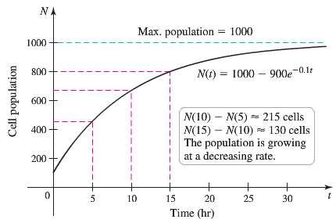 







The graph of the population function shows that the population increases, but at a decreasing rate. Note that the initial condition  cells is satisfied and that population size approaches 1000 cells as .

***Example***

A book publisher estimates that the marginal cost of a particular title (in dollars/book) is given by



Where  is the number of books printed. What is the cost of producing the 12,001st through the 15,000 book?

***Solution***











***Exercises Section* 1.1 – Velocity and Net Change**

Assume *t* is time measured in seconds and velocities have units of *m/s*.

1. Graph the velocity function over the given interval. Then determine when the motion is in the positive direction.
2. Find the displacement over the given interval.
3. Find the distance traveled over the given interval.

|  |  |  |
| --- | --- | --- |
|  |  |  |

Consider an object moving along a line with the following velocities and initial positions

1. Graph the velocity function on the given interval. Then determine when the object is moving in the positive direction and when it is moving in the negative direction.
2. Determine the position function for  using both the antiderivative method and the Fundamental Theorem of Calculus. Check for agreement between the two methods.
3. Graph the position function on the given interval.

|  |  |
| --- | --- |
|  |  |

Find the position and velocity of an object moving along a straight line with the given acceleration, initial velocity, ansd initial position. Assume units of meters and seconds.

|  |  |
| --- | --- |
|  |  |

1. A mass hanging from a spring is set in motion and its ensuing velocity is given by  for . Assume that the position direction is upward and .
2. Determine the position function for .
3. Graph the position function on the interval [0, 3].
4. At what times does the mass reach its lowest point the first three times?
5. At what times does the mass reach its highest point the first three times?
6. The velocity of an airplane flying into a headwind is given by  *mi/hr* for . Assume that 
7. Determine and graph the position function for .
8. How far does the airplane travel in the first 2 *hr*.?
9. How far has the airplane traveled at the instant its velocity reaches 400 *mi/hr*.?
10. A car slows down with an acceleration of . Assume that  and 
11. Determine and graph the position function for .
12. How far does the car travel in the time it takes to come to rest?
13. The owners of an oil reserve begin extracting oil at . Based on estimates of the reserves, suppose the projected extraction rate is given by , where , *Q* is measured in millions of barrels, and *t* is measured in years.
14. When does the peak extraction rate occur?
15. How much oil is extracted in the first 10, 20, and 30 years?
16. What is the total amount of oil extracted in 40 year?
17. Is one-fourth of the total oil extracted in the first one-fourth of the extraction period? Explain.
18. Starting with an initial value of , the population of a prairie dog community grows at a rate of  (in units of prairie *dogs/month*), for 
19. What is the population 6 months later?
20. Find the population  for 
21. The population of a community of foxes is observed to fluctuate on a 10-year cycle due to variations in the availability of prey. When population measurements began (*t* = 0 years), the population was 35 foxes. The growth rate in units of *foxes/yr*. was observed to be



1. What is the population 15 years later? 35 years later?
2. Find the population  at any time 
3. A strong west wind blows across a circular running track. Abe and Bess start at the south end of the track and at the same time, Abe starts running clockwise and Bess starts running counterclockwise. Abe runs with a speed (in units of *mi/hr*.) given by  and Bess runs with a speed given by , where *φ* and *θ* are the central angles of the runners

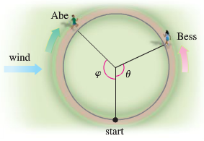

1. Graph the speed functions *u* and *v*, and explain why they describe the runners’ speed (in light of the wind).
2. Which runner has the greater average speed for one lap?
3. If the track has a radius of , how long does it take each runner to complete one lap and who wins the race?
4. A reservoir with a capacity of 2500  is filled with a single inflow pipe. The reservoir is empty and the inflow pipe is opened at *t* = 0. Letting  be the amount of water in the reservoir at time *t*, the flow rate of water into reservoir (in ) oscillates on 24-*hr* cycle and is given by



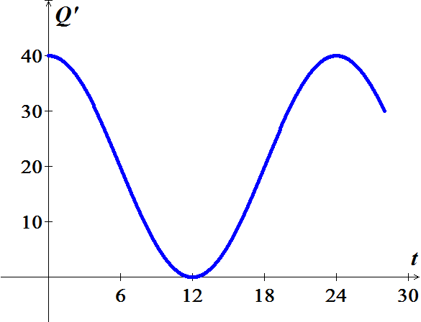

Flow rate of water (m3/hr.)

1. How much water flows into the reservoir in the first 2 *hrs*.?
2. Find and graph the function that gives the amount of water in the reservoir over the interval  where .
3. When is the reservoir full?
4. The velocity of an object moving along a line is given by . What is the displacement of the object after 1.5 *sec*?
5. A projectile is launched vertically from the ground at , and its velocity in flight (in *m/s*) is given by . Find the position, displacement, and distance traveled after *t* seconds, for 
6. At , a car begins decelerating from a velocity of 80 *ft/s* at a constant rate of . Find its position function assuming .
7. The acceleration of an object moving along a line is given by . The initial velocity and position are  and 
8. Find the velocity and position for 
9. What are the minimum and maximum values of *s*?
10. Find the average velocity and average position over the interval 
11. Starting at the same point on a straight road, Anna and Benny begin running with velocities (in *mi/hr*) given by  and , respectively.
12. Graph the velocity functions, for .
13. If the runners run for 1 *hr*, who runs farther? Interpret your conclusion geometrically using the graph in part (*a*).
14. If the runners run for 6 *mi* who wins the race? Interpret your conclusion geometrically using the graph in part (*a*).
15. A small plane in flight consumes fuel at a rate (in *gal/min*) given by



1. Find a function *R* that gives the total fuel consumed, for 
2. Find a function *R* that gives the total fuel consumed, for 
3. If the fuel tank capacity is 150 *gal*, when does the fuel run out?
4. Water flows out of a tank at a rate  given by . If the tank initially holds 75  of water, when will the tank be empty?
5. A projectile is fired upward, and its velocity in *m/s* is given by .
6. Graph the velocity function, for .
7. When does the velocity reach 50 *m/s*?
8. Find and graph the position function for the projectile for , assuming .
9. Given unlimited time, can the projectile travel 2500 *m*? If so, at what time does the distance traveled equal 2500 *m*?
10. A projectile is fired upward, and its velocity in *m/s* is given by .
11. Graph the velocity function, for .
12. Find and graph the position function for the projectile for , assuming .
13. Given unlimited time, can the projectile travel 2500 *m*? If so, at what time does the distance traveled equal 2500 *m*?
14. Jeff and Mel took a bike ride, both starting at the same time and position. Jeff started riding at 20 *mi/hr*, and his velocity decreased according to the function . Mel started riding at 15 *mi/hr*, and her velocity decreased according to the function 
15. Find and graph the positions of Jeff and Mel.
16. Find the times at which the riders have the same position at the same time.
17. Who ultimate took the lead and remained in the lead?